Hello World RESTful Web Service
Created a controller class
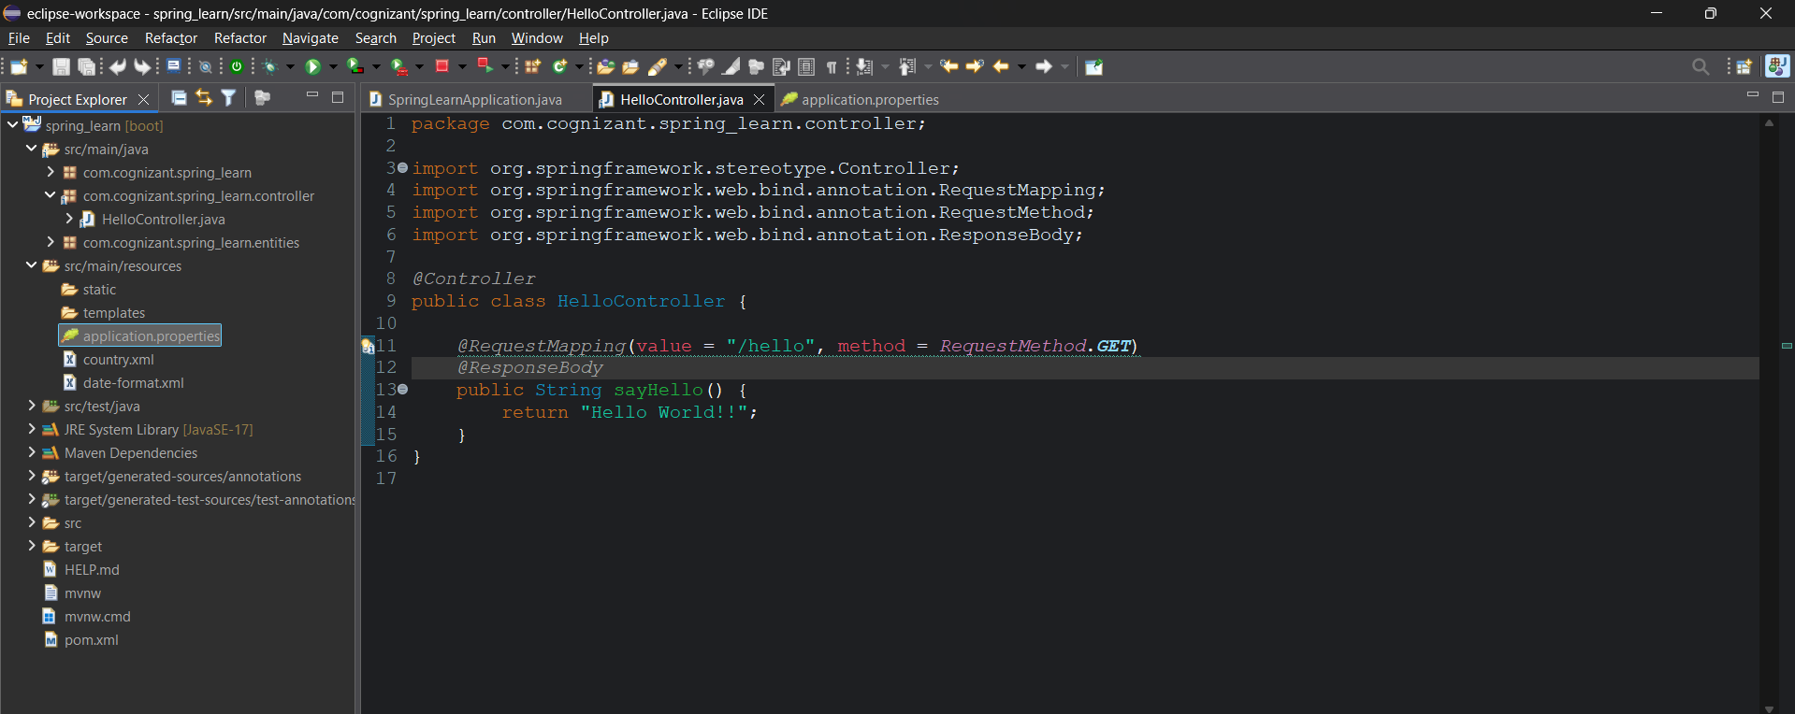
Started the server at 8083 port
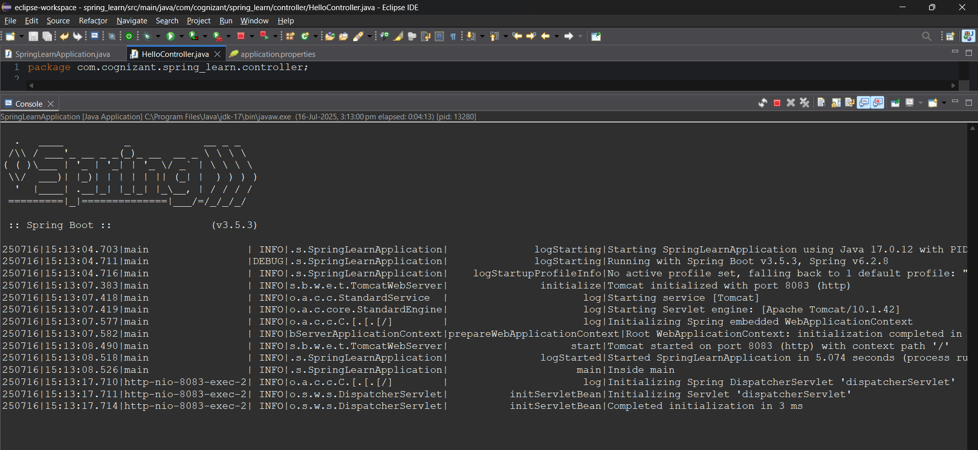
Postman: (sending request from postman)
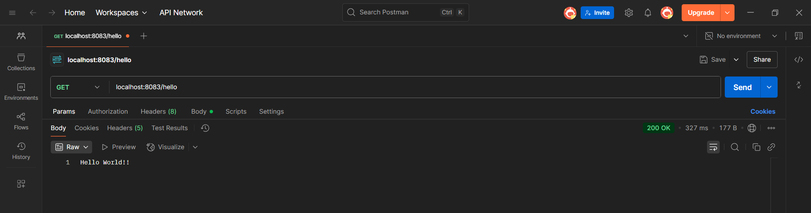
Browser: (sending the request from the browser)
